Google Meet – Videoconferencing Guide

Google Meet is a videoconferencing solution created by Google company, which enables real-time transmission of voice and images and provides the possibility of sharing presentations, instant messages (chat), etc.
Installation of any additional programmes is not required. In order to use Google Meet on a mobile device, it is necessary to install Google Meet application which is available in common app-stores (Google Play, AppStore).
Notice: For the best performance of Google Meet use Google Chrome browser
How to join video conference
A video-conference host books the conference and shares a link with participants. For example, the following is how the link may look like: meet.google.com/yvk-tfuv-cwm
Clicking on the link, a new web-browser window opens with a button „Allow the access permission“. Participants can join the conference when the conference host allows the permission.
Notice: In order to join the conference, a participant is required to have an open Google account. If a participant does not have a Google account, the web-browser will ask him/her to register in order to continue joining the conference.
During the initial activation of the video conference, web-browser and operating system may require certain permissions, such as permission to access camera, microphone and network. For smooth functioning of devices, it is necessary to allow these permissions. Google Meet will indicate that it is necessary to allow the permissions, and the user should give them in the right menu of the web-browser (Figure 1).
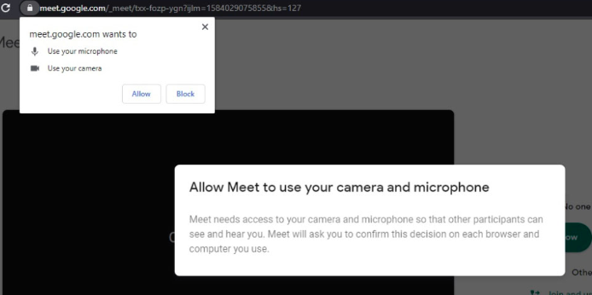
Figure 1 – Permission to access microphone
In a default Google Meet layout, users are displayed in the right part of the window, where the tab for instant messages (chat) is located – Figure 2.
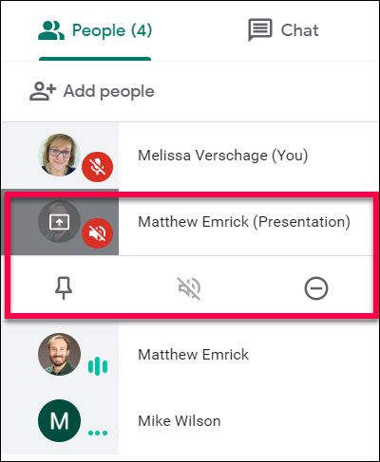
Figure 2 – View options and user control options
Notice: When joining the conference, turn off the microphone to prevent loud noise.
Conference presenting
Upon joining the conference, participants can deliver their presentations by selecting the appropriate options in the right menu (Figure 3). For sharing the content with other participants, it is necessary to prepare a window with the presentation or web page which should be shared. Participants can share a window, entire screen or web-reader card (in which the conference started).
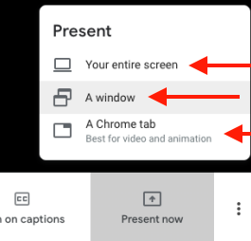
Figure 3 – Presentation options
Notice: Please open the programme for presentations first (e.g. PowerPoint), and then click on the screen share. Thus, PowerPoint window will be activated among other active screens that can be shared.
Users can end the presentation by clicking the appropriate button on the main menu.
Important: If it happens that you somehow get out of the meeting, you can get back by clicking on the button “Rejoin” in your browser, or by using the meeting link.

